M Street
NO DROP OFF OR PICK UP ON M STREET
NO DROP OFF OR PICK UP ON M STREET

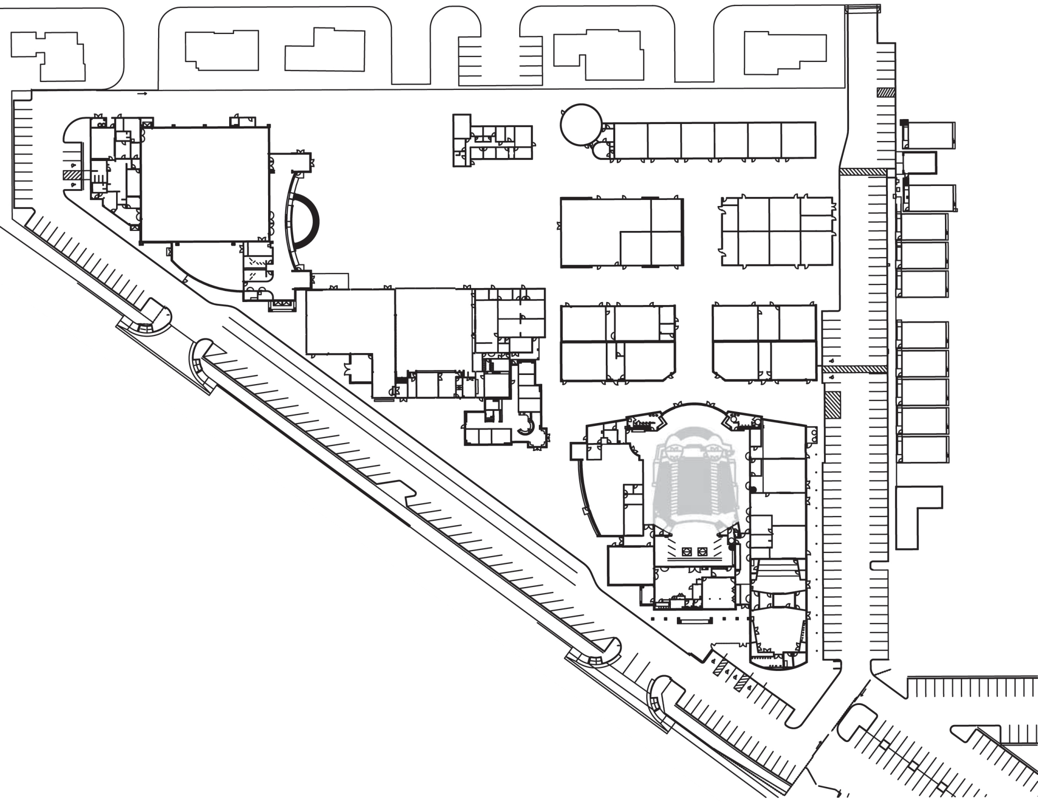
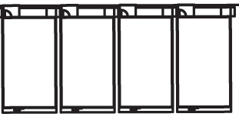

Advancement
House
500
501 502 503

St. Clare
Dining Hall
Administration 200 Chapel

300
Canticle Garden

301 302 303 304 305

506
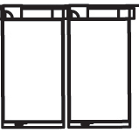

505 504

Gym/Fitness
Center

Serra Court

Campus Life
Center

311

312

313

314
315

507

508

Troubie
Store
320

Student Activities
Office
321
322 323
324

509

510

Guidance Cafeteria
Maintenance
EXIT HERE
330
331
332
333

511

340 341
342 343
512

513
NO DROP OFF OR PICK UP

DROP OFF AND PICK UP ONLY

North
ELVAS AVE
St. Francis
Administration 100

Library/ Resource Center

408

Arts
Complex

400

401

402

403
514

515

407
MORNING DROP OFF: Please utilize green arrows
AFTERNOON PICK UP: Please utilize blue, then green arrows
No parking in drop off/pick up area

404

406

405

ENTER HERE

5900 Elvas Avenue • Sacramento, CA 95819 • 916.452.3461 • Fax 916.452.1591 • www.stfrancishs.org
DO NOT ENTER

