Ch 4 A Tour of the Cell

Concept 4.1 Biologists use Microscopes & The tools of biochemistry to study cells

Cell Fractionation

Cell fractionation breaks up cells and separates the components, using centrifugation

Cell components separate based on their
relative size

Cell fractionation enables scientists to determine the functions of organelles

Concept 4.2: Eukaryotic cells have internal membranes that compartmentalize their functions

The basic structural and functional unit of every organism is one of two types of cells: prokaryotic or eukaryotic

Comparing Prokaryotic and Eukaryotic Cells

Basic features of all cells

Plasma membrane

Semifluid substance called cytosol

Chromosomes (carry genes)

Ribosomes (make proteins)

Comparing Prokaryotic and Eukaryotic Cells

Eukaryotic Cells: Plant vs. Animal
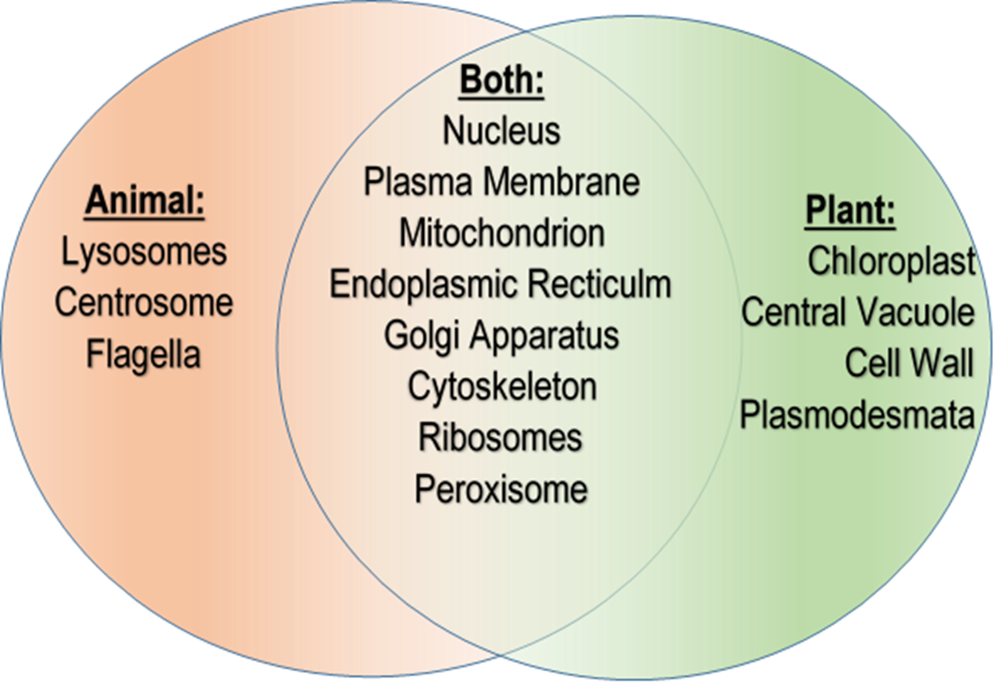

The Plasma Membrane

Figure 4.5
- The plasma membrane is a selective barrier that allows sufficient passage of oxygen, nutrients, and waste to service the volume of every cell
- The general structure of a biological membrane is a double layer of phospholipids

Surface Area:Volume Ratio

Figure 4.6: Surface Area:Volume Ratio

Metabolic requirements set upper limits on the size of cells

The ratio of surface area to volume of a cell is critical

Higher S:V ratio allows more diffusion

To successfully support the metabolic requirements a cell needs to be SMALL

A Panoramic View of the Eukaryotic Cell

A eukaryotic cell has internal membranes that divide the cell into compartments—organelles

The plasma membrane and organelle membranes participate directly in the cell’s metabolism

Concept 4.3: The eukaryotic cell’s genetic instructions are housed in the nucleus and carried out by the ribosomes

The nucleus contains most of the DNA in a eukaryotic cell

Ribosomes use the information from the DNA to make proteins

Figure 4.8

Figure 4.9

Concept 4.4: The endomembrane system regulates protein traffic and performs metabolic functions in the cell

Components of the endomembrane system

Nuclear envelope

Endoplasmic reticulum

Golgi apparatus

Lysosomes

Vacuoles

Plasma membrane

These components are either continuous or connected through transfer by vesicles

The Endoplasmic Reticulum: Biosynthetic Factory

The endoplasmic reticulum (ER) accounts for more than half of the total membrane in many eukaryotic cells

The ER consists of a network of sacs and tubules
- ER lumen is the internal compartment of the ER
- Cisternae fluid filled membranous sacs and tubules

There are two distinct regions of ER

Smooth ER: lacks ribosomes
- Synthesizes lipids & steroids (ie: steroid hormones lots in ovaries & testies)
- Metabolizes carbohydrates
- Detoxifies drugs and poisons
- Stores calcium ions

Rough ER: surface is studded with ribosomes
- Polypeptide (proteins) made in bound ribosomes, thread into inside of the rough ER
- These dpolypeptides get folded into their 3D shape (2nd-ary & Tertiary structure
- Has bound ribosomes, which secrete glycoproteins
- Distributes transport vesicles, proteins surrounded by membranes
- Is a membrane factory for the cell

Figure 4.10

The Golgi Apparatus: Shipping & Receiving Center
- The Golgi apparatus consists of flattened membranous sacs called cisternae
- Cis- vs Trans face
- Functions of the Golgi apparatus
- Modifies (attaches ID tags that act like “zip codes” on mailing labels) on to products of the ER
- Manufactures certain macromolecules
- Sorts and packages materials into transport vesicles
- Not just a wharehouse for receiving, sorting and shipping but also dynamic modification of cargo (cisternal maturation model)

Figure 4.11

Lysosome Formation

The hydrolytic enzemes and lysosome membranes are made by the rough ER and Golgi apparatus

A lysosome is a membranous sac of hydrolytic enzymes that can digest macromolecules for food or recycling old organelles

Lysosomal enzymes can hydrolyze proteins, fats, polysaccharides, and nucleic acids

Lysosomal enzymes work best in the acidic environment inside the lysosome

Figure 4.12

Some types of cell (macrophage – type of WBC) (amoebas) can engulf another cell by phagocytosis; this forms a food vacuole

A lysosome fuses with the food vacuole and digests the molecules

Figure 4.13 pg 80

Lysosomes also use enzymes to recycle the cell’s own organelles and macromolecules, a process called autophagy

This helps cell to renew themselves (ie: Liver cells)

Vacuoles: Diverse Maintenance Compartments

Vacuoles are large vesicles derived from the endoplasmic reticulum and Golgi apparatus

Membrane bound storage organelle

There are several types:

Food vacuoles are formed by phagocytosis

Contractile vacuoles, found in many freshwater protists, pump excess water out of cells

Central vacuoles, found in many mature plant cells, hold organic compounds (waste products, pigments & chemical compounds that could be poisonous) and water

Certain vacuoles in plants and fungi carry out enzymatic hydrolysis like lysosomes

Figure 4.14 pg 80

The Endomembrane System: A Review

The endomembrane system is a complex and dynamic player in the cell’s compartmental organization

Figure 4.15

The Evolutionary Origins of Mitochondria and Chloroplasts

Mitochondria and chloroplasts have similarities with bacteria

Enveloped by a double membrane

Contain free ribosomes and circular DNA molecules

Grow and reproduce somewhat independently in cells

The endosymbiont theory

An early ancestor of eukaryotic cells engulfed a non-photosynthetic prokaryotic cell, which formed an endosymbiont relationship with its host

The host cell and endosymbiont merged into a single organism, a eukaryotic cell with a mitochondrion

At least one of these cells may have taken up a photosynthetic prokaryote, becoming the ancestor of cells that contain chloroplasts

Figure 4.16 pg 82

Mitochondria: Chemical Energy Conversion

Mitochondria are in nearly all eukaryotic cells & are the energy producers

They have a smooth outer membrane and an inner membrane folded into cristae

Cristae allow for grater surface area for cell respiration

The inner membrane creates two compartments:

intermembrane space and

mitochondrial matrix = liquidy inside inner membrane

Mito has own DNA & ribosomes

Some metabolic steps of cellular respiration are catalyzed in the mitochondrial matrix

Break down sugars to produce energy in the form of ATP (Adenasine TriPhophate)

Cristae present a large surface area for enzymes that synthesize ATP

In cells with a lot of metabolic activity there are a lot (1000s) of mitochondria

Figure 4.17

Chloroplasts: Capture of Light Energy

Chloroplasts are energy producers

Chloroplasts contain the green pigment chlorophyll, as well as enzymes and other molecules that function in photosynthesis

Chloroplast structure includes

2 membranes (inner & outer)

Thylakoids, membranous sacs, stacked to form
a granum (grana=plural)

Stroma, the internal fluid

The chloroplast is one of a group of plant organelles called plastids

Plastids store starch, have pigments to give flowers colors

Chloroplastss have own DNA and

Figure 4.18a

Peroxisomes: Oxidation

Peroxisomes are specialized metabolic compartments bounded by a single membrane

Peroxisomes contain enzymes that remove hydrogen from certain molecules and transfer them to Oxygen producing hydrogen peroxide (as a byproduct) which is toxic but they can break down H2O2 & convert it to water

Peroxisomes perform reactions with many different functions

Ie: Liver peroxisomes detoxify alcohol by transferring the Hydrogen from the alcohol and other harmful compounds to oxygen

Figure 4.19 pg, 84

Concept 4.6: The Cytoskeleton is a network of fibers that organizes structures & activities in the cell

The cytoskeleton is a network of fibers extending throughout the cytoplasm

It organizes the cell’s structures and activities, anchoring many organelles

Figure 4.20 pg. 84

Three main types of fibers make up the cytoskeleton

Microtubules are the thickest of the three components of the cytoskeleton

Microfilaments, also called actin filaments, are the thinnest components

Intermediate filaments are fibers with diameters in a middle range

Table 4.1 pg 86

Centrosomes and Centrioles

In animal cells, microtubules grow out from a centrosome near the nucleus

The centrosome is a “microtubule-organizing center”

The centrosome has a pair of centrioles, each with nine triplets of microtubules arranged in a ring

Figure 4.22

Cilia and Flagella

Microtubules control the beating of cilia and flagella, microtubule-containing extensions projecting from some cells

Flagella are limited to one or a few per cell, while cilia occur in large numbers on cell surfaces

Cilia and flagella also differ in their b eating patterns

Cilia like row boat oars stroking back & forth

Flagella undulate or “S-wave” pattern

Cilia and flagella share a common structure

A core of microtubules sheathed by the plasma membrane (cytoskeleton) w/9+2 pattern

With 9 + 2 pattern: 9 pairs(doublets) around central pair

A basal body that anchors the cilium or flagellum

A motor protein called dynein, which drives the bending movements of a cilium or flagellum, uses ATP

Cell Walls of Plants

The cell wall is an extracellular structure that distinguishes plant cells from animal cells

The cell wall protects the plant cell, maintains its shape, and prevents excessive uptake of water

Plant cell walls are made of cellulose fibers embedded in other polysaccharides and protein

Figure 4.25

The Extracellular Matrix (ECM) of Animal Cells

Animal cells lack cell walls but are covered by an elaborate extracellular matrix (ECM)

ECM helps:

support,

move,

regulate cell behavior &

Adhere cells to other cells

Figure 4.26 pg 89

The ECM is made up of glycoproteins such as collagen, proteoglycans, and fibronectin

ECM proteins bind to receptor proteins in the plasma membrane called integrins

Cell Junctions

Neighboring cells in an animal or plant often adhere, interact, and communicate through direct physical contact

There are several types of intercellular junctions that facilitate this

Plasmodesmata

Tight junctions

Desmosomes

Gap junctions

Plasmodesmata are channels that perforate plant cell walls

Through plasmodesmata, water and small solutes (and sometimes proteins and RNA) can pass from cell to cell

Animal cells have three main types of cell junctions:

Tight junctions

Membranes of adjacent cells are fused, forming continuous belts around cells;

Prevent fluids from leaking in/out

Ie: TJs between skin cells make us water tight by preventing leakage btwn cells in our sweat glands

Desmosomes

Anchoring junctions like “Rivets”

Fasten cells together into strong sheets

Ie: Desmosomes attach muscle cells

Gap junctions

Communicating junctions

Allows cystoplasm, ions, sugars, amino acids, & other small molecules to move between adjacent animal cells

Ie: heart muscle, brain cells

All are especially common in epithelial tissue

Figure 4.27 pg 90

