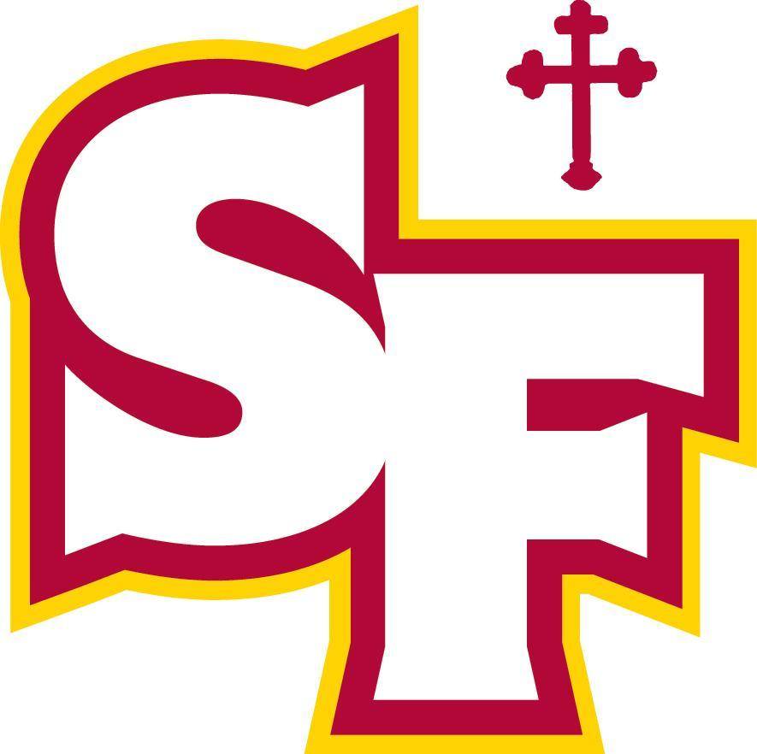

Copying Files from your SFHS Troubie Mail to your Personal Email:
Google Takeout Instructions

Create an account:
If you haven't already, create a Google Account. Your new email address will be your username@gmail.com.

Start the copy process
- On your school account, go to Transfer your content.
- Enter the email address of the Google Account where you want to copy your content.
- Select Get code.
- On your Google Account, check your Gmail inbox for a confirmation email from Google. In the email, select Get confirmation code. A new tab will open with a code.
- On your school account, go back to the "Transfer your content" page. Enter the code, then choose Verify.
- Choose the content you'd like to copy, then select Start transfer.

If the above steps do not take you through the process automatically you can do this manually by following the steps below:

Navigate to “My Account” or from the App Launcher in the upper, right-hand corner or “Manage My Account” from your icon

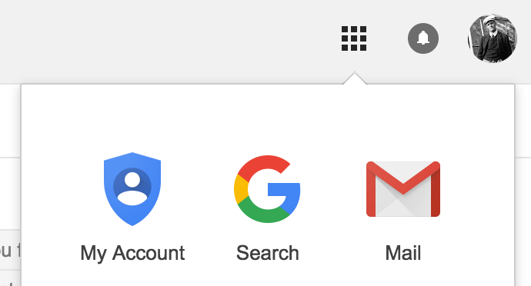

2. Select “Transfer your content

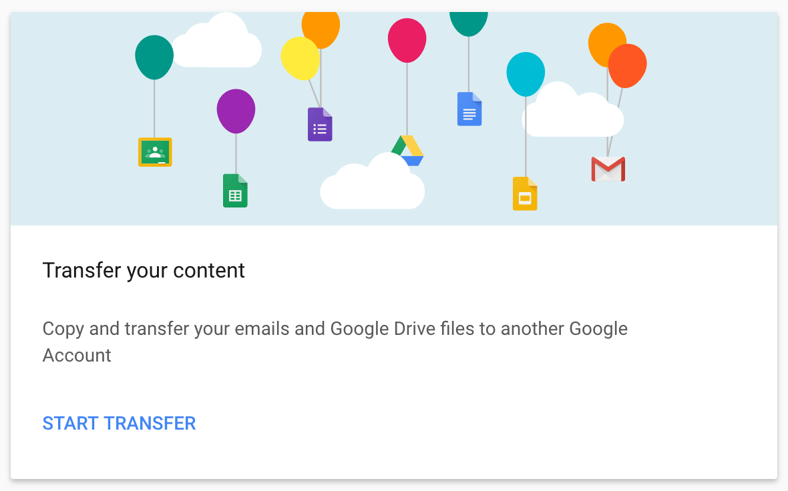

4. From there you will have three simple steps to complete. You will need an active Gmail account in order to transfer your documents.

Note: you will be given options to transfer everything from Drive and everything from Gmail. You cannot pick and choose what you want to transfer from within Drive. Additionally, you will most likely not want to transfer all your emails over since that will flood your personal account with every email from your SF account.

Other important information
We will keep your SFHS email-enabled through the summer. Email accounts will be deactivated in early September.

The Chromebook is yours to keep. If you will not be using it in the future consider donating it back to SFHS as we give them to our Catholic feeder schools.

Below is a link on how to “ Wipe” your school-managed Chromebook and remove all SFHS restrictions.

Wipe School Managed Chromebook

